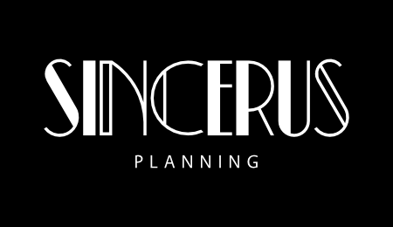

FULL PLANNING APPLICATION

PLANNING, DESIGN AND ACCESS STATEMENT

DEMOLITION OF 2NO. EXISTING COMMERCIAL BUILDINGS AND REPLACEMENT WITH 2N0. NEW PURPOSE BUILT COMMERCIAL BUILDINGS, ALONG WITH ASSOCIATED CAR PARKING AND ANCILLARY WORKS

NOVEMBER 2023

CONTENTS

Chapter 1 Introduction

Chapter 2 Site and Surroundings

Chapter 3 Planning History

Chapter 4 Development Proposals

Chapter 5 Planning Policy Context

Chapter 6 Key Considerations

Chapter 7 Conclusions

- INTRODUCTION

Background

  - This Planning, Design and Access Statement is submitted in relation to the following development proposal at 550-555 Llantrisant Road, Pontypridd:

‘Demolition of 2No. existing commercial buildings and replacement with 2No. new purpose built commercial buildings, along with associated car parking and Ancillary Works’

Information Submitted in Support of Application

  - The following information has been prepared in support of the planning application:

- Drawings – Provided by Roger Evans Architects:

Site Location Plan at 1:1250
Dwg No. BP1 - Proposed Block Plan;
Dwg No.1 – Building 1 Floor Plan;
Dwg No.2 – Building 2 Floor Plan;
Dwg No.3 – Elevations Building 1;
Dwg No.4 – Elevations Building 2:
Broadway Building 1 NP Wilson Design Drawing;
Broadway Building 2 NP Wilson Design Drawing;
Dwg No.110 - Footway and Carriageway Construction; and
Dwg No.111 – Vehicular Crossover Construction.

- David Clements Ecology Survey For Bats and Nesting Birds (dated November 2023).

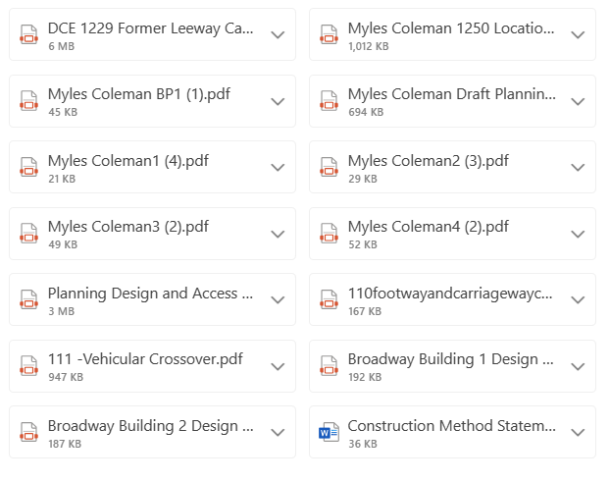

Purpose and Structure of this Statement

  - This Statement outlines the context in which the application is made, and provides a detailed examination of the main planning considerations raised by the proposals, together with reasoned justification in support of the proposed development.

  - The statement is structured as follows:

- Section 2 - Description of the characteristics of the site and surrounding area;
- Section 3 – Planning history of relevance to the site;
- Section 4 - Development proposals;
- Section 5 - Relevant planning policy framework;
- Section 6 – Analysis of the key planning considerations; and
- Section 7 - Conclusions.

- SITE AND SURROUNDINGS

The Site

  - The application site has a long history of varied commercial use and is currently occupied by two single storey buildings which are in commercial use. The larger of the two buildings was most recently occupied by Leeway Carpets and Flooring and consists of a showroom along with ancillary offices and storage and the second building (the smaller of the two was formerly occupied by W2C Building Contractors).

  - The applicant’s ownership extends to the area as indicated by the red line below, which measures circa 2,250 square metres:

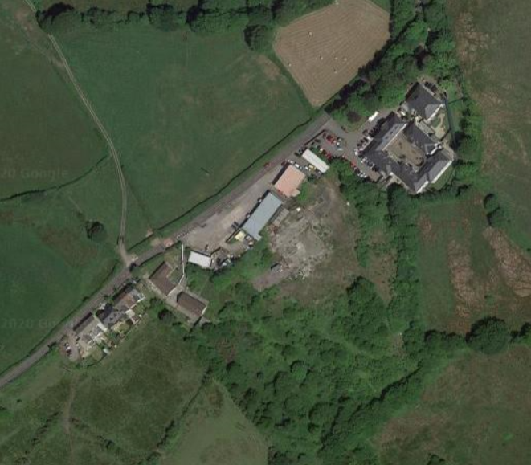
Aerial Image of Application Site

Surroundings

  - The site is located within Penycoedcae which is 2.2 Kms from the centre of Pontypridd and is located within the Electoral Ward of Beddau.

  - Surrounding the site is:

- To the North East – Economy Auto Centre and CJ Autos (car repair garages);

The vehicular repair business known as Economy Auto Centre falls outside of the boundaries of the application site. This building is of a height comparable with a two storey building. Beyond the vehicular repair garages is a modern two storey development known as Heatherwood Court, which is a secure private hospital.

- South East – Former Scrap yard;

The scrap yard has ceased trading and the site has largely been cleared of material. The site consists of areas of hardstanding and scrub.

- South West – Residential properties

The property is neighboured by residential properties to the south west, closest to the site are two bungalows, which are set off the shared boundary and at a slightly higher ground level (rising up the hill towards the heart of Penycoedcae) with two story dwellings beyond.

- North West – Llantrisant Road and countryside beyond

Llantrisant Road passes along the entire frontage of the application site and provides access to the site. Beyond the public highway is a grass verge and hedgerow with agricultural land beyond, which falls away to the north;

  - The site benefits from good road and public transport links into Pontypridd and beyond. The site is a 2.2km from Pontypridd train station and this can be cycled in 8 minutes or alternatively, the site is located directly on a bus route which provides access into Pontypridd and, which takes 11 minutes using bus service 404.

Site Photographs

  - Below are images of the application site taken from Llantrisant Road:

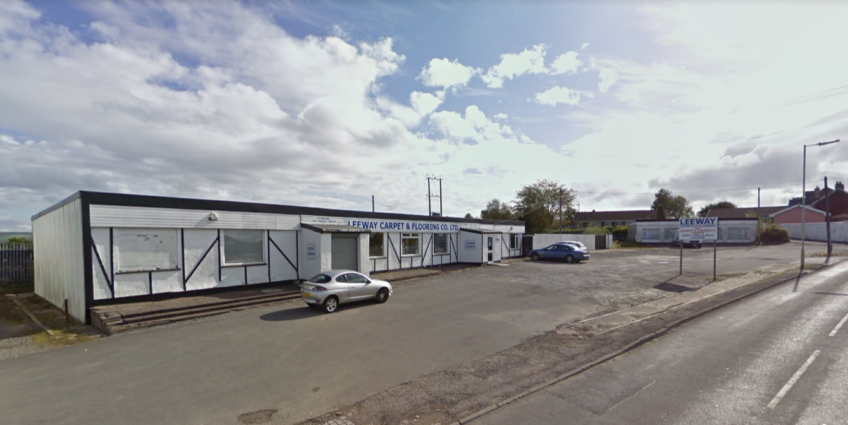
View of Application Site Facing South East Llantrisant Road

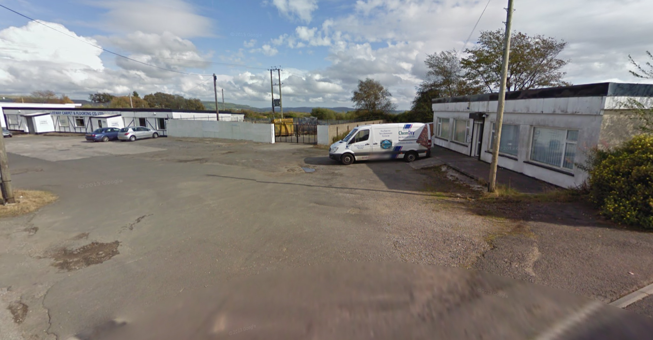
View of Application Site Facing North East from Llantrisant Road

- PLANNING HISTORY

Planning History

3.1 An application search was undertaken using the LPA’s on-line search facility and the results are shown in the table below.

Application Ref | Description | Decision | Decision Date
22/0326/15 | Variation of condition 1 (Time period) 17/0874/15 | Decision Pending (106 Agreement) | N/A
20/0158/10 | Demolition of 2 No. existing commercial buildings and replacement with a new purpose built premises with a store/cutting room and retail showroom along with associated car parking and landscaping and ancillary works. | Approved | 01/11/2021
17/0874/15 | Variation of Condition 1 (Time Period) and Removal of Condition 15 (Sustainable Homes) of previous application 10/1084/10. | Approved | 27/04/2018
17/5062/41 | Replace existing retail / industrial unit, demolish single storey unit and construction of 5 new dwellings. | Approved | 11/08/2017
10/1084/10 | Residential Development – re development of commercial carpet premises | Refused | 23/07/2013

3.2 The below table includes a list of relevant planning history for neighbouring sites:

Application Ref | Description | Decision | Decision Date
13/0363/10 | Two new single storey extensions to provide additional communal living space and new external access steps to a private room | Approved | 15/07/2013

10/1084/10

3.3 In July 2013 planning permission 10/1084/10 was granted for the demolition of both existing buildings on site and the erection of 6no. dwellings, as shown on the approved Proposed Site Plan below:

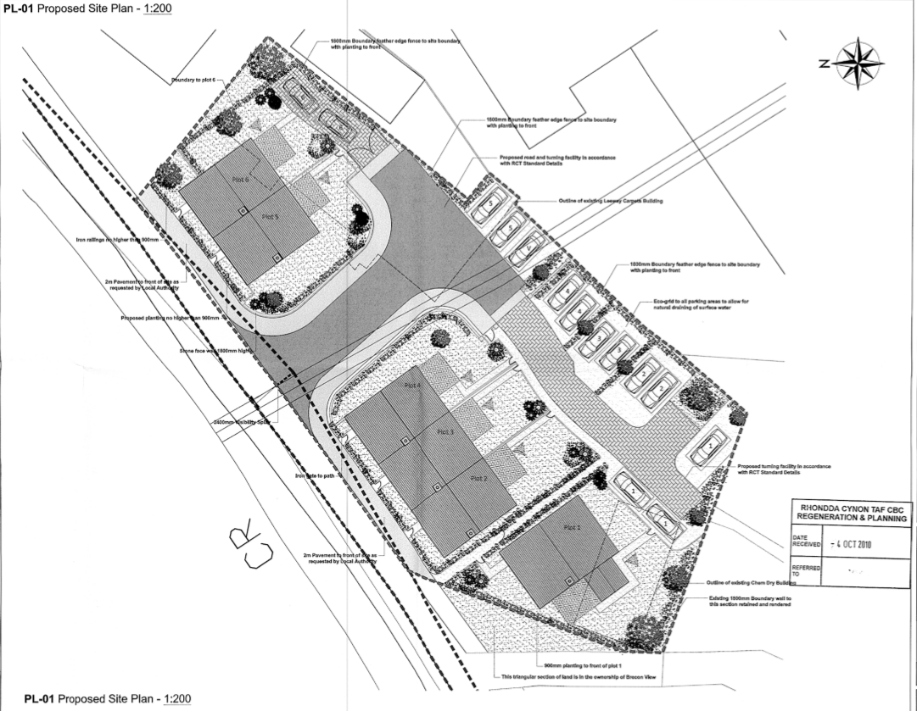

Approved Proposed Site Plan

3.4 In April 2018 permission 17/0874/15 was granted to extend the period for the commencement of development of planning permission 10/1084/10 until 27/04/2023.

17/5062/41

3.5 In August 2017 planning permission was granted to retain the existing Leeway Carpets & Flooring building and to construct a terrace of 5no. two storey dwellings.

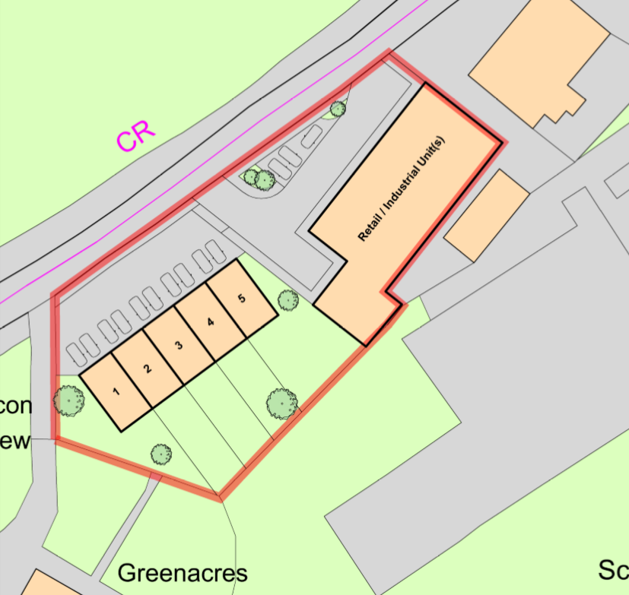
Approved Proposed Site Plan

3.6 The above proposed scheme granted permission for a significant increase in the volume of development on the site and the replacement of the existing 92 square metres industrial building with a terrace of 5no. two storey dwellings.

20/0158/10

3.7 In November 2021 permission was granted for the ‘Demolition of 2 No. existing commercial buildings and replacement with a new purpose-built premises with a store/cutting room and retail showroom along with associated car parking and landscaping and ancillary works’.

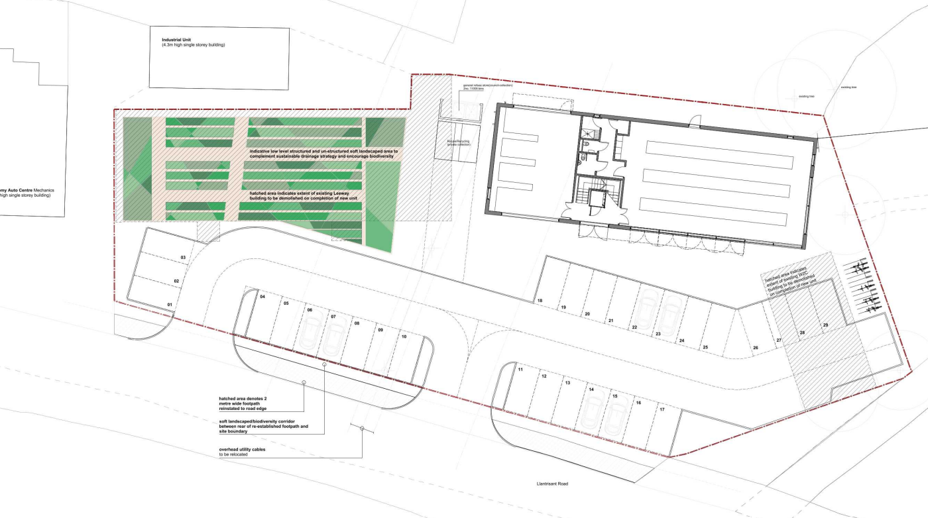
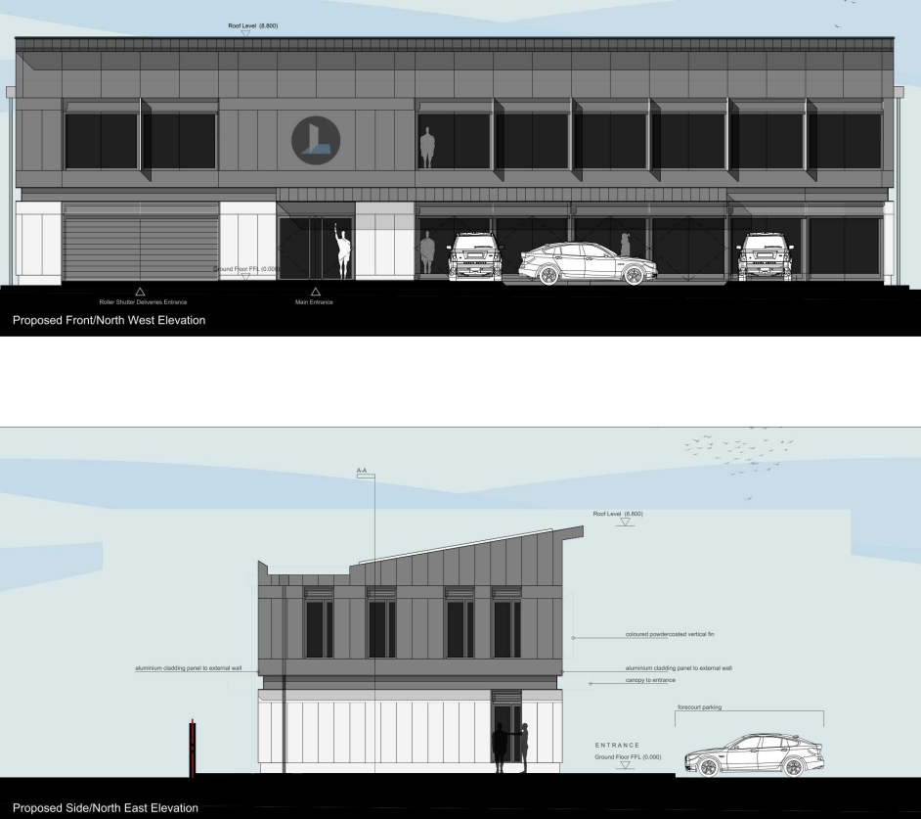

- DEVELOPMENT PROPOSALS

Description

  - The enclosed application is for Planning Permission for the following development proposal:

‘Demolition of 2No. existing commercial buildings and replacement with two new purpose built premises, along with associated car parking and landscaping and Ancillary Works’

The Proposed Works

4.2 The proposed site plan below shows the two proposed new commercial buildings, along with vehicular parking, and refuse and recycling storage facilities.

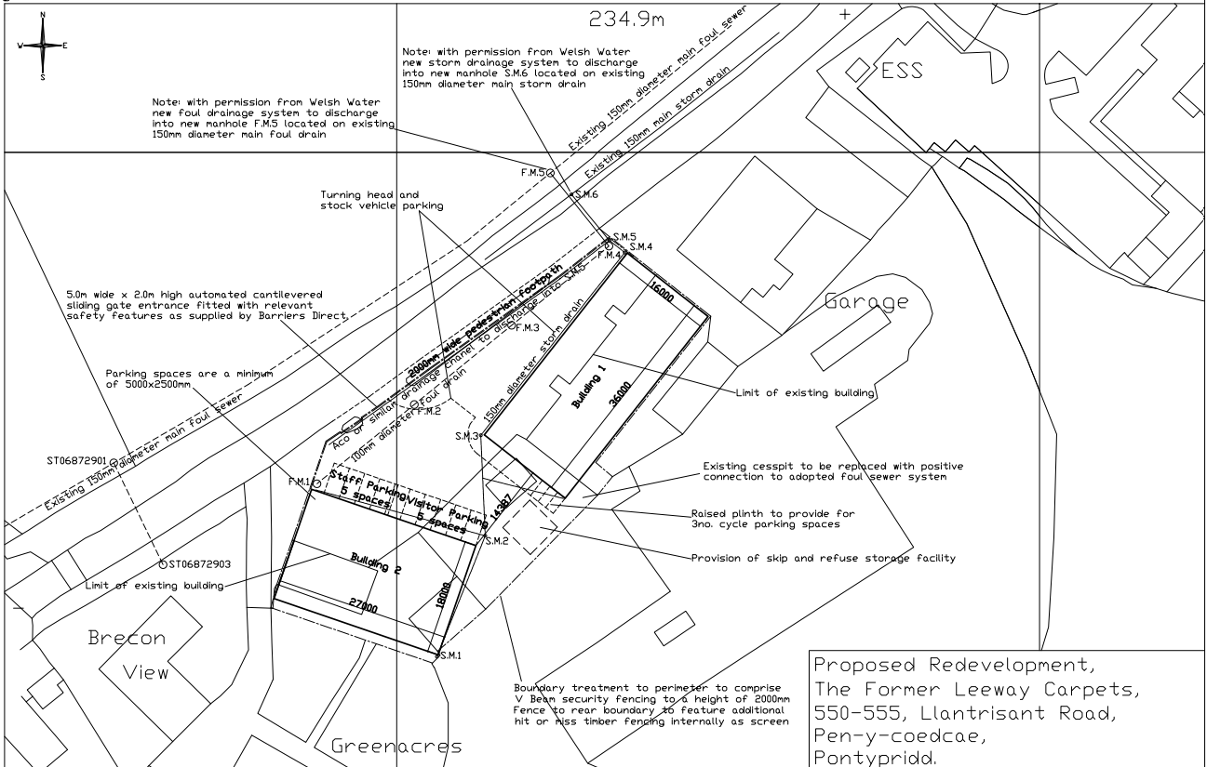
Proposed Site Plan

4.3 The edge of the site with the public footway and Llantrisant Road is currently in very poor condition, with extended lengths of drop kerb, broken and poorly formed sections of footway, resulting in pedestrian safety issues. The proposed redevelopment includes the reinstatement of the public footway and reduction in the vehicular crossover length. It is also proposed to install a 5 Metres wide automated cantilevered sliding gate at the entrance to the site, which will assist in delineating more clearly the vehicular access to the site.

4.4 The drawing extracts below show the elevations and plans of proposed building 1.

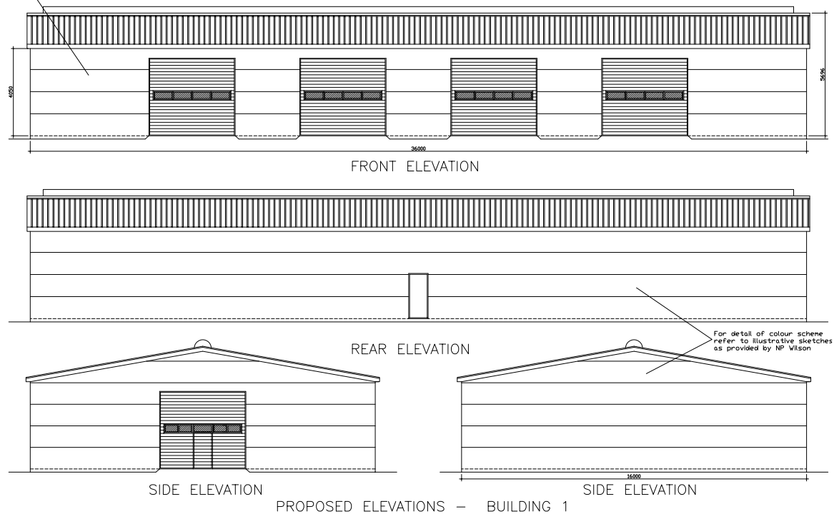

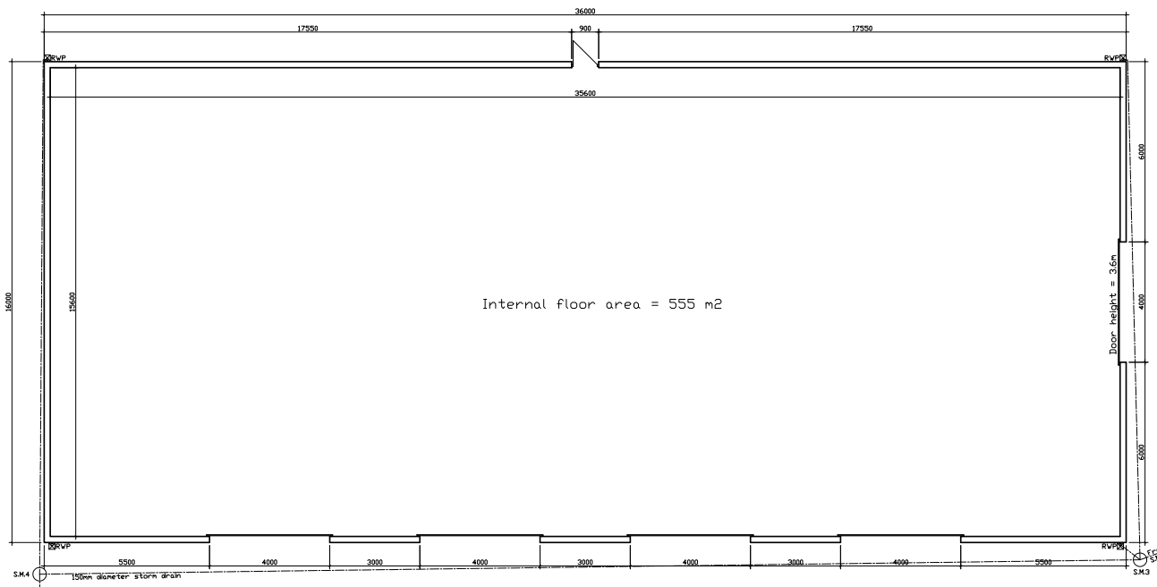
Proposed Building 1 Floor Plan

4.5 The drawing extracts below show the elevations and plans of proposed building 2.

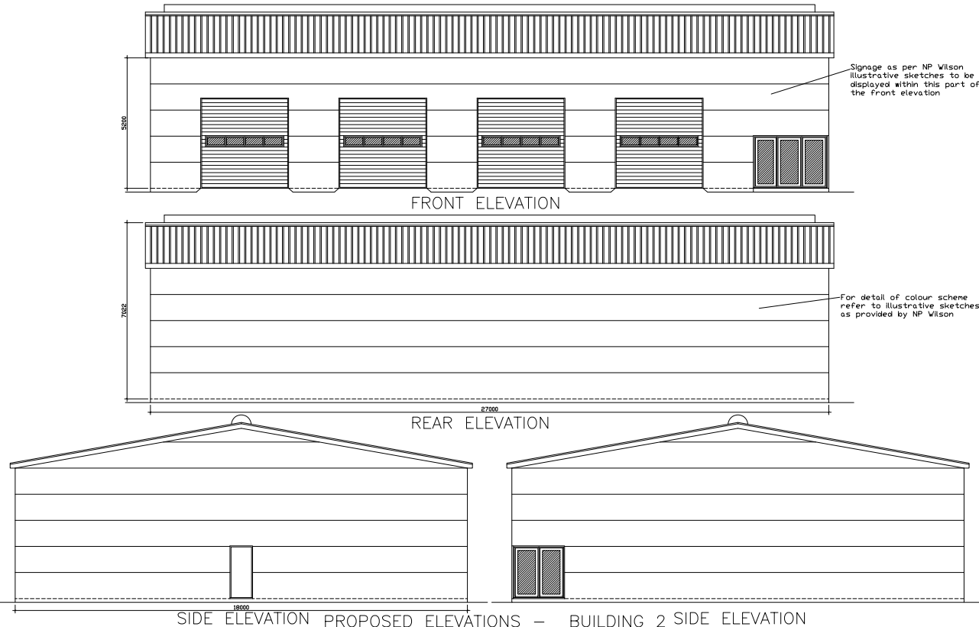
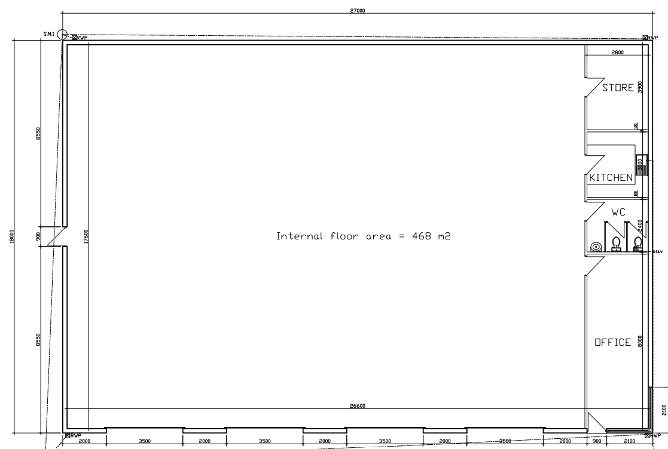
Proposed Building 2 Floor Plan
4.6 The images below are provided by NP Wilson Ltd, the manufacturers of the commercial buildings. The images provide a clearer understanding regarding the material finish and colours of the proposed materials and the general aesthetic quality of the development.

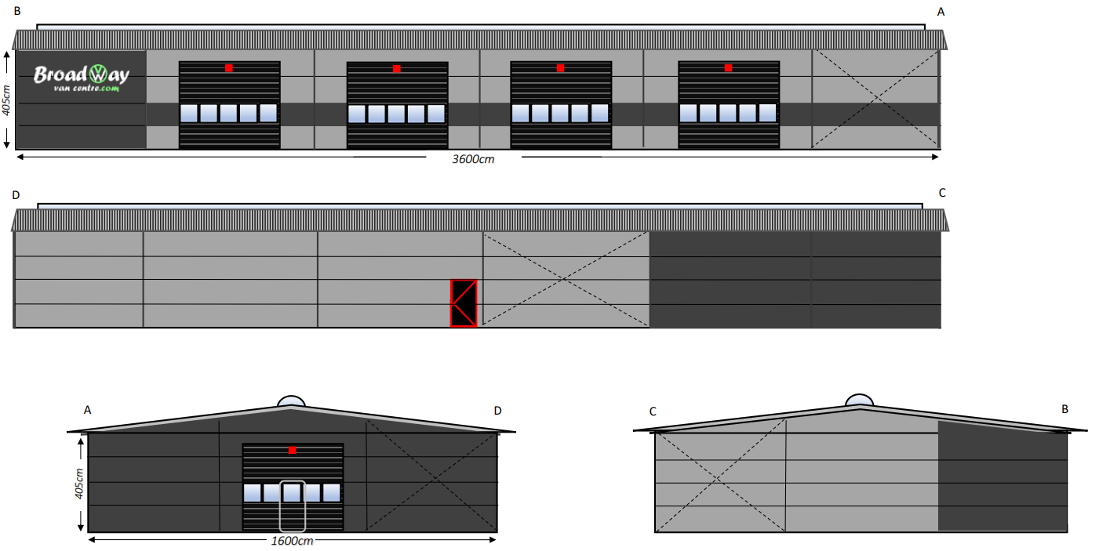

Building 1 Elevations

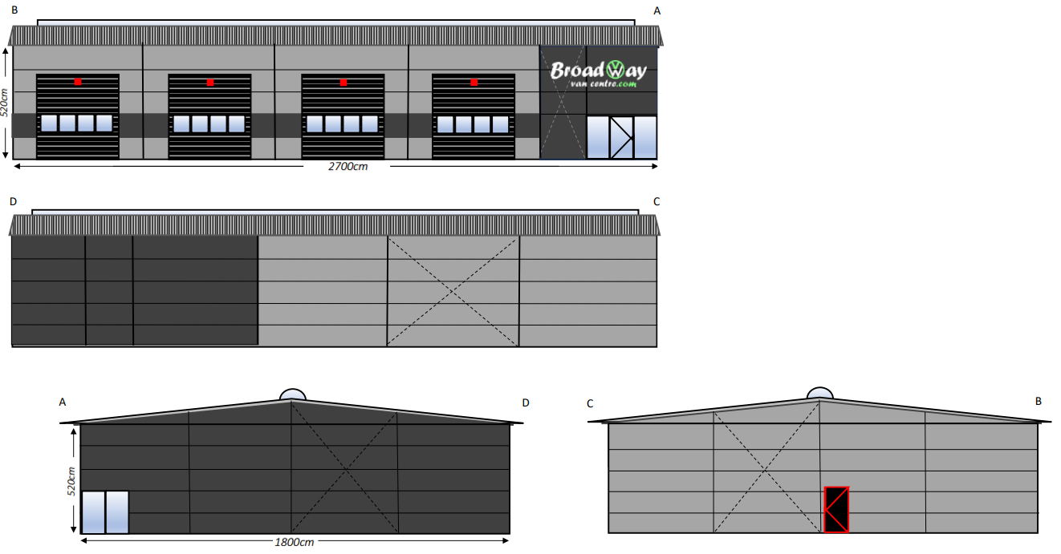
Building 2 Elevations

4.7 The proposed buildings are to be finished as follows:

Walls: Microgroove boards, mounted horizontally, in black and light grey colour;
Fenestration: Double glazed windows and doors, anthracitre grey in colour;
Sectional Doors: Insulated doors with feature glazing, anthracite in colour;
Roof: Panels of anthracite colour; and
Rainwater Goods: Colour to match walls.

4.8 The proposed steel framed buildings are proposed to be clad with panels, which are designed to provide a high level of acoustic insultation of 26 (-3;-4) dB. Below are extracts from the manufacturers specification sheet for the cladding materials:
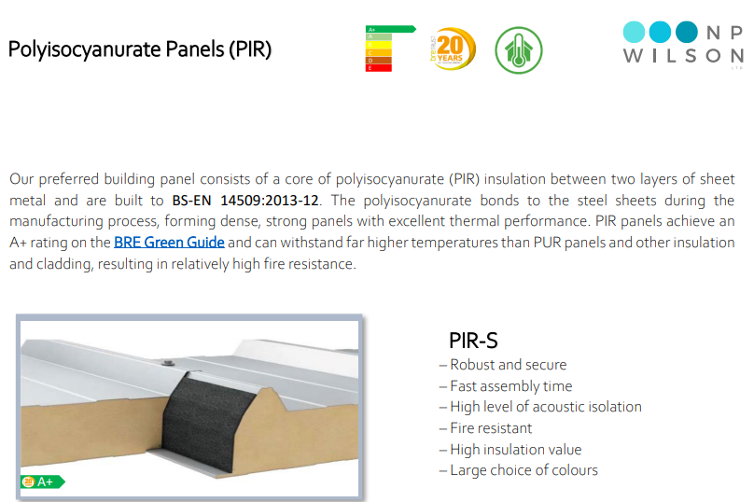
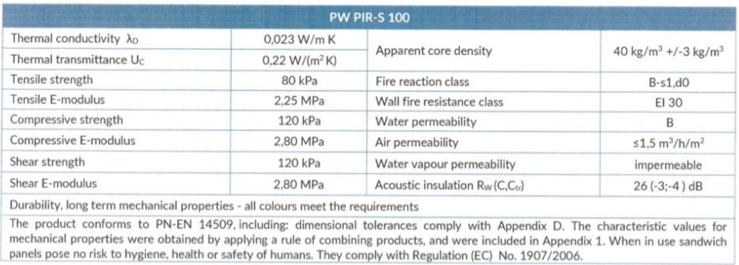

- PLANNING POLICY CONTEXT

5.1 A review of the planning policy context associated with the site and proposed development (at the national and local level) is provided within this section of the Planning Statement.

5.2 The key planning policies of relevance to the determination of the application, which have been given due consideration are outlined below.

National Planning Policy

5.3 The following policy / guidance documents prepared at the National (Welsh Government) level are of relevance to the determination of the application.

Planning Policy Wales (11th Edition), February 2021

5.4 Planning Policy Wales (PPW) forms the overarching national planning policy document within Wales, providing guidance to Local Planning Authorities (LPAs) for the preparation of development plans and the determination of planning applications through their development management functions. It is considered that the following PPW chapters are pertinent to the determination of this application:

5.5 PPW 11 identifies that planning policies, decisions and proposals should:

- Promote resource-efficient and climate change resilient settlement patterns that minimise land-take through preference for the re-use of suitable previously developed land and buildings;
- Support the need to tackle the causes of climate change;
- Maximise well-being and create sustainable places through placemaking;
- Minimise the risks posed by, or to, development on or adjacent to unstable or contaminated land and land liable to flooding;
- Play an appropriate role to facilitate sustainable building standards;
- Play an appropriate role in securing the provision of infrastructure to form the physical basis for sustainable communities;
- Contribute to the protection and improvement of the environment;
- Help to ensure the conservation of the historic environment and cultural heritage, acknowledging and fostering local diversity;
- Maximise the use of renewable resources, including sustainable materials;
- Encourage opportunities to reduce waste and all forms of pollution and promote good environmental management and best environmental practice;
- Promote quality, lasting, environmentally-sound and flexible employment opportunities; and
- Support initiative and innovation and avoid placing unnecessary burdens on enterprises so as to enhance the economic success of both urban and rural areas.

5.6 Paragraph 3.55 emphasises the preference of previously developed land as opposed to greenfield sites. The paragraph advises that “in settlements such land should generally be considered suitable for appropriate development where its re-use will promote sustainability principles and any constraints can be overcome.”

5.7 Para 4.1.10 states that:

The planning system has a key role to play in reducing the need to travel and supporting sustainable
transport, by facilitating developments which:

- Are sited in the right locations, where they can be easily accessed by sustainable modes of travel and without the need for a car;
- Are designed in a way which integrates them with existing land uses and neighbourhoods; and
- Make it possible for all short journeys within and beyond the development to be easily made by walking and cycling.

Technical Advice Notes

5.8 Technical Advice Notes (TANs) supplement the policy principles of PPW and add further detail on issues which might affect development potential of the site. TANs which are considered relevant to the proposal and should therefore be given weight are:

TAN | Title
TAN 4 | Retail and Commercial Development (2016)
TAN 12 | Design (2016)
TAN 18 | Transport (2007)
TAN 23 | Economic Development (2017)

Technical Advice Note (TAN) 4 – Retail and Commercial Development (2016)

5.9 Technical Advice Note (TAN) 4 provides guidance to LPAs regarding the allocation of land for retail and commercial development, along with the assessment of planning applications for such development. It is considered that the following paragraphs are pertinent to the determination of this application:

‘Suitability

7.2 Suitability refers to a site or building’s attributes and whether these are sufficient to meet the development requirements of a particular proposal. Where a developer favours a development site on the edge of or outside a retail and commercial centre the developers will need to provide evidence to explain why potential sites or buildings within the centre are unable to accommodate the format, scale and design of a proposed development. This exercise should not necessarily be confined to an individual centre and developers should consult with the local planning authority to ascertain the extent of any search for other potentially suitable sites or buildings within the wider catchment area.

7.3 When a need for further convenience or comparison shopping provision is established as part of the development plan preparation process the local planning authority should consider how different retail formats, could be accommodated on a site. Where allocated sites are on the edge of or outside retail and commercial centres local planning authorities should give consideration to the possible consequences of any subdivision of units that may be proposed by developers in the future and whether measures are required to restrict any such proposals. Developers seeking to include sites in development plans should be flexible and innovative, and should examine carefully how sites in established centres may be able to accommodate their requirements’.

Technical Advice Note (TAN) 12 – Design (2016)

5.10 Technical Advice Note (TAN) 12 provides guidance regarding design matters. It is considered that the following paragraphs are pertinent to the determination of this application:

5.11 Further detailed guidance on the objectives of good design is provided within TAN 12. The objectives of good design are set out within the following categories:

Access
- Ensuring ease of access of all.

Movement
- Promoting sustainable means of travel.

Sustaining or Enhancing Local Character
- Promoting legible development;
- Promoting a successful relationship between public and private space;
- Promoting quality, choice and variety;
- Promoting innovative design.

Community Safety
- Ensuring attractive, safe public spaces;
- Security through natural surveillance.

Environmental Sustainability
- Achieving efficient use and protection of natural resources;
- Enhancing biodiversity;
- Designing for change.

Technical Advice Note 18: Transport (2007)

5.12 Technical Advice Note (TAN) 18 provides guidance regarding Transport issues. It is considered that the following paragraphs are pertinent to the determination of this application:

5.13 This TAN describes how to integrate land use and transport planning, it explains how transport impacts should be assessed and mitigated. It includes advice on transport related issues when planning for new development including integration between land use planning and transport, location of development, parking and design of development. Also, on walking and cycling, public transport, planning for transport infrastructure, assessing impacts and managing implementation.

‘It is for the applicant to provide the local planning authority with sufficient information to allow the assessment of their proposals in respect of scheduled monuments, listed buildings, conservation areas, registered historic parks and gardens, World Heritage Sites, or other sites of national importance and their settings. These principles, however, are equally applicable to all historic assets, irrespective of their designation. For any development within the setting of a historic asset, some of the factors to consider and weigh in the assessment include:

• The significance of the asset and the contribution the setting makes to that significance;
• the prominence of the historic asset;
• the expected lifespan of the proposed development;
• the extent of tree cover and its likely longevity; and
• non-visual factors affecting the setting of the historic asset such as noise.

The local planning authority should be able to provide guidance to the applicant during preapplication discussions on the amount of information required to support a proposal. This may include providing a heritage impact statement if the proposal is likely to have an impact on a historic asset. How setting is to be addressed by the applicant should also be considered as part of any preapplication discussions.

Other factors which may affect the setting of a historic asset include; inter-visibility with other historic or natural features, tranquility, noise or other potentially polluting development though it may have little visual impact.

There will be cases where a proposed development will enhance the setting of a historic asset and this will be treated as a benefit resulting from the development. Mitigation of damaging effects could be achieved through good design and in some cases screening or landscaping’.

Technical Advice Note 23: Economic Development

5.14 Technical Advice Note (TAN) 23 provides guidance regarding Economic Development. It is considered that the following paragraphs are pertinent to the determination of this application:

5.15 Planning and the market

‘1.2.1 The economic benefits associated with development may be geographically spread out far beyond the area where the development is located. As a consequence it is essential that the planning system recognises, and gives due weight to, the economic benefits associated with new development.

PPW advises that planning for economic land uses should aim to provide the land that the market requires, unless there are good reasons to the contrary. Where markets work well, this will help maximise economic efficiency and growth’.

‘1.2.4 Such instances can be widespread and PPW highlights corrections in many places. Among other things, the policy advises that planning should guide development so that it benefits disadvantaged communities, concentrates people-intensive activities in town centres and aligns jobs with housing and infrastructure. Market forces on their own do not necessarily deliver these sustainable objectives’.

‘2.1.1 It should not be assumed that economic objectives are necessarily in conflict with social and environmental objectives. Often these different dimensions point in the same direction. Planning should positively and imaginatively seek such ‘win-win’ outcomes, where development contributes to all dimensions of sustainability’.

‘2.1.6 Alternatives: if the land is not made available (the site is not allocated, or the application is refused), is it likely that the demand could be met on a site where development would cause less harm, and if so where?

This test follows from the principle in PPW5, that the planning system should steer development to the most sustainable locations. When a proposed site allocation or development scheme is rejected the associated economic activity will usually be redirected to another site. To gauge the benefit of the proposal, it will be necessary to compare it with the ‘base case’ in which the proposal does not go ahead. The answer relates partly to the locational flexibility of the economic sectors concerned. For example, retail and local consumer services usually mean that demand can be more easily steered to alternative sites within the local authority area or sub-region. At the other extreme, some internationally footloose operations may not locate in Wales, or remain in Wales at all, unless they secure a particular site. Similarly some existing firms may not be able to grow unless they are allowed to expand on their existing site, or close to it. Before concluding that ‘there is no alternative’ local planning authorities are encouraged to try to assess whether competing firms, serving the same markets, could generate the same development and jobs. This would generally require close liaison with the local authority Economic Development Department or other appropriate stakeholders (see 4.1.1) who might have detailed knowledge of the capacity and expertise of firms in the area or sub-area.

This approach requires an analysis of the availability of similar alternative sites nearby, but not necessarily in the same local authority. If the subject site is unexceptional, there are many others like it, and these other sites have spare capacity, it may be easy to find substitutes. Conversely, there may be few substitutes or none if the subject site has unusual advantages, such as very large size, outstandingly good accessibility, or specialist features that certain industries need. But unusual characteristics only matter if they match market requirements. If large single-user sites or prestige office parks, for example, are oversupplied, it would be wrong to sacrifice environmentally sensitive land for the sake of increasing supply’.

Jobs accommodated: how many direct jobs will be based at the site?

This provides an approximate measure of a development’s contribution to the wider economy. Economic growth is worthwhile wherever it is located, and in the interests of economic growth the planning system should generally aim to provide land where there is demand for it6. A local authority may wish to conduct a more detailed assessment of potential job creation taking in to account indirect job creation. There may be good reasons why jobs in some places are even more worthwhile than in other places. The third test below deals with this.

Special merit: would the development make any special contribution to policy objectives?

Such policy contributions may relate to the objectives listed in PPW7, or to more general policy objectives set out elsewhere in PPW. For example, a major employment site may be a key element of a wider spatial strategy which aligns jobs, development and infrastructure. The office or production plant of a high-technology firm could bring supply-side benefits by raising skills and introducing innovation. An industrial estate in a disadvantaged area could help fight social exclusion, improving run-down places and creating job opportunities for people at high risk of unemployment.

PPW advises that the planning system should particularly support the low-carbon economy, innovative business / technology clusters and social enterprises which are defined as businesses that are particularly important in providing opportunities for social groups disadvantaged in the labour market. Developments that will provide space for these categories of businesses count as making special policy contributions. This assessment of special policy contributions has to be largely qualitative but it can, and should, be rigorous, including critical review of applicants’ claims. In particular, claims about jobs and physical regeneration for disadvantaged communities need careful consideration, taking account of displacement. If jobs housed in new development displace jobs that are within or close to the disadvantaged area, then there is no employment benefit to the community concerned.

Planning authorities should use these criteria comparatively. They should assess the additional benefits of development at the subject site (if any) against those of meeting demand in locations where the development would cause no harm (if any). For example: A greenfield development could attract high-value, high-skill businesses – which arguably would not be interested in a lower-quality environment. In assessing the development, the key question is whether an equally attractive setting could be created in places that are less environmentally sensitive. Conversely, an urban brownfield redevelopment might create local jobs and physical regeneration in an area of need, at the cost of traffic congestion and bad neighbour nuisance. Alternatively, the development could be located in a sustainable urban extension a short distance away, the development could be environmentally benign, but may be socially less useful’.

‘Existing employment sites

4.6.7 Certain industrial and related uses may conflict with other uses, especially housing. To operate effectively, these activities usually need dedicated industrial areas, where they can be confident that they will not be a bad neighbour to anyone. In managing the retention and release of existing employment sites authorities should aim to ensure that the integrity of remaining employment sites is not compromised.

The traditional employment uses tend to generate lower land values than many other land uses, especially housing and retail, consequently, any land lost to these uses is generally difficult to replace. Planning authorities should avoid releasing for other uses sites where there is strong evidence of likely future need for B1-B8. In some areas, older, lower-cost employment areas may be required, especially for small and new firms who cannot afford newer and more prestigious accommodation. The loss of such areas may cause harm to local economies and should be avoided’.

Local Planning policy

5.16 The Rhondda Cynon Taff Local Development Plan was adopted by the Authority in March 2011 and is intended to form the key policy document until 2021.

5.17 Below is the relevant extract from the Local Development Plan Proposals Map which includes the application site:

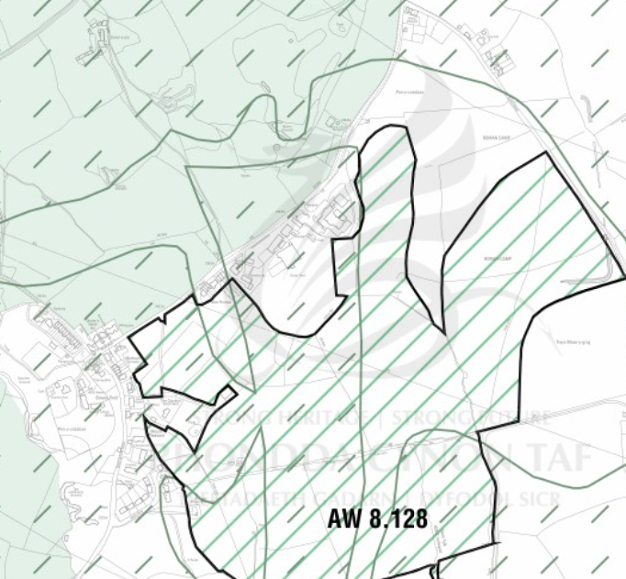
Proposals Map East Extract

Rhondda Cynon Taff Local Development Plan Proposals Map Key
 | SINC – Site of Important Nature Conservation - AW 8 |  | Special Landscape Area NSA 25 and SSA 23
 | Sandstone Resources AW 14.2

5.18 The below is the relevant extract from the Local Development Plan Constraints Map which includes the application site:

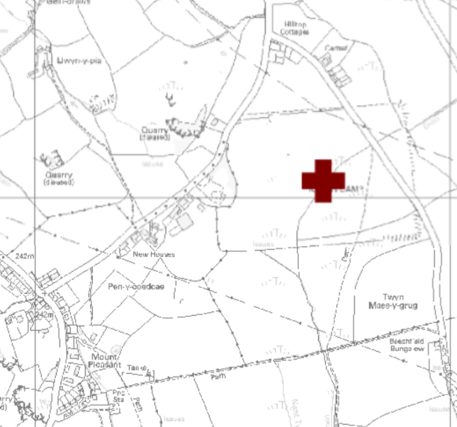
LDP Constraints Map Extract

Rhondda Cynon Taff Local Development Plan Proposals Map Key
Scheduled Ancient Monument

5.19 The application site is located within the Southern Strategy Area of the LDP, as shown on the map extract below:

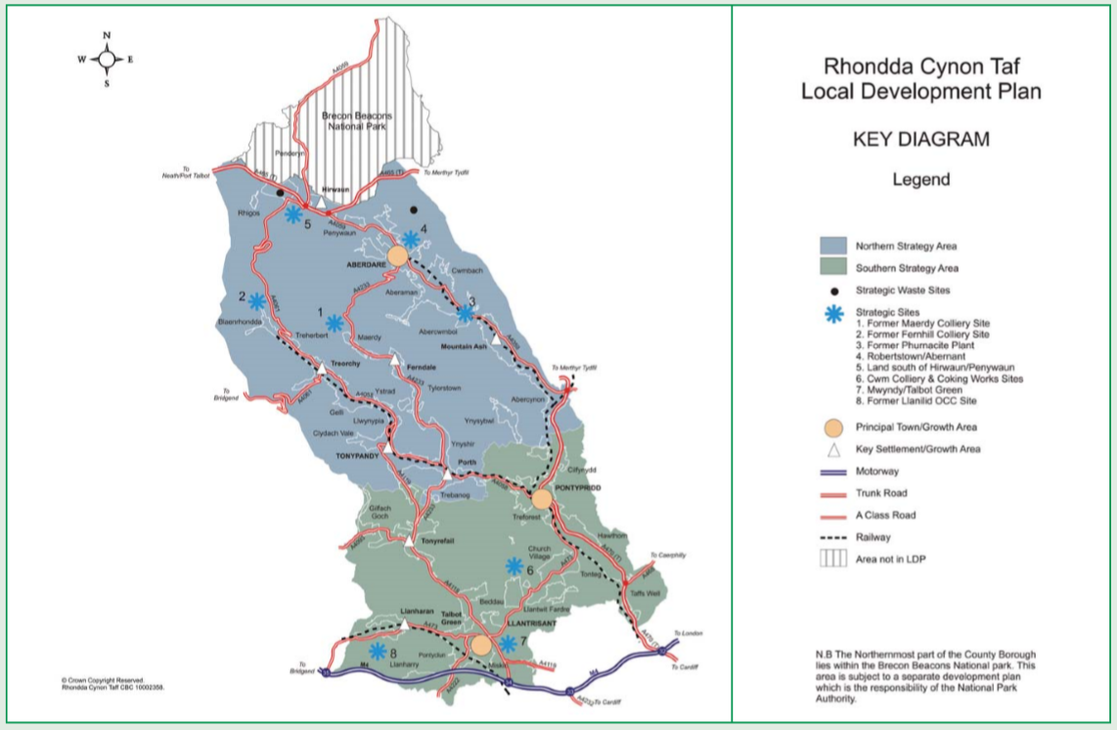
RCT LDP Key Diagram

5.20 Below are the Policies of the Local Development Plan which are considered to be of most relevance to the proposals for consideration:

- Policy CS2 Development in the South;

‘In the Southern Strategy Area the emphasis will be on sustainable growth that benefits Rhondda Cynon Taf as a whole. This will be achieved by:

- Promoting residential development with a sense of place which respects the character and context of the Principal Towns and Key Settlements of the Southern Strategy Area;

- Protecting the culture and identity of communities by focusing development within defined settlement boundaries and promoting the reuse of under used and previously developed land and buildings;

3. Promoting large scale regeneration schemes in the Principal Town of Pontypridd and Key Settlement of Tonyrefail;

- Realising the importance of the Principal Town of Llantrisant / Talbot Green as an area of social and economic growth;

5. Providing opportunities for significant inward investment, in sustainable locations, that will benefit the economy of Rhondda Cynon Taf and the Capital Region;

6. Reducing daily out commuting by private car and promoting sustainable forms of transport;

7. Protecting the cultural identity of the Strategy Area by protecting historic built heritage and the natural environment, and 8.Promoting and enhancing transport infrastructure services to support growth and investment’.

The amplicfication text for the policy states:

5.21 ‘The key location of the Southern Strategy area means that it has a vital role to play in ensuring the future economic prosperity of Rhondda Cynon Taf. Economic growth however, must be carefully managed in order to ensure that the social and environmental needs of the Strategy Area are fully addressed.

The LDP will seek to manage residential and commercial growth in the Southern Strategy Area in a manner that seeks to balance the economic potential of the area with environmental capacity’.

Policy AW 2 - Sustainable Locations

5.22 ‘In order to ensure that development proposals on non-allocated sites support the objectives of the plan, development proposals will only be supported in sustainable locations. Sustainable locations are defined as sites that:–

- Are within the defined settlement boundary or in the Northern Strategy Area, accord with Policy NSA 12;
- Would not unacceptably conflict with surrounding uses;
- Have good accessibility by a range of sustainable transport options;
- Have good access to key services and facilities;
- Do not permit highly vulnerable development and Emergency Services within Zone C2 floodplain. Within Zone C development will be permitted where it can be justified that: -
a) It is necessary to assist the regeneration of a Principal Town or Key Settlement including the key employment objectives, or where development involves a large brownfield site.
b) The potential consequences of a flooding event have been considered and found to be acceptable in accordance with national guidance and meet the definition of previously developed land.
- Support the roles and functions of the Principal Towns, Key Settlements and Small Settlements;
- Support the development of the 8 Strategic Sites;
- Are well related to existing water, sewerage, waste, electrical, gas and telecommunications infrastructure and improvements to such services will be provided where necessary.
- Where proposals relate to existing buildings in the countryside, accord with AW 9’.

AW 4 ‘Community Infrastructure and Planning Obligations’

5.23 Indicates when planning obligations may be sought in order to make the proposal acceptable in planning terms.

Policy AW 5 - New Development

5.24 ‘Development proposals will be supported where:

- Amenity

a)The scale, form and design of the development would have no unacceptable effect on the character and appearance of the site and the surrounding area;
b)Where appropriate, existing site features of built and natural environment value would be retained;
c)There would be no significant impact upon the amenities of neighbouring occupiers;
d)The development would be compatible with other uses in the locality;
e)The development would include the use of multi-functional buildings where appropriate;
f)The development designs out the opportunity for crime and anti social behaviour.

2) Accessibility

a)The development would be accessible to the local and wider community by a range of sustainable modes of transport;
b)The site layout and mix of uses maximises opportunities to reduce dependence on cars;
c)The development would have safe access to the highway network and would not cause traffic congestion or exacerbate existing traffic congestion;
d)Car parking would be provided in accordance with the Council’s Supplementary Planning Guidance on Delivering Design and Placemaking: Access, Circulation and Parking Requirements’.

Policy AW 6 - Design and Placemaking

5.25 ‘Development Proposals will be supported where:

1.They are of a high standard of design, which reinforces attractive qualities and local distinctiveness and improves areas of poor design and layout;
2.They are appropriate to the local context in terms of siting, appearance, scale, height, massing, elevational treatment, materials and detailing;
3.In the case of extensions to buildings, they reflect, complement or enhance the form, siting, materials, details and character of the original building, its curtilage and the wider area;
4.In the case of proposals for new and replacement shop fronts and signage, they make a positive contribution to the streetscene;
5.In the public realm and key locations such as town centres, major routes, junctions and public spaces, the character and quality of the built form is to a high standard of design;
6.They include public art;
7.Landscaping and planting are integral to the scheme and enhance the site and the wider context;
8.They include an integrated mixture of uses appropriate to the scale of the development;
9.They include the efficient use of land, especially higher-density residential development on sites in proximity to local amenities and public transport;
10.Open space is provided in accordance with the Fields in Trust Standards;
11.A high level of connectivity and accessibility to existing centres, by a wide range of modes of sustainable transport;
12.Schemes incorporate a flexibility in design to allow changes in use of buildings and spaces as requirements and circumstances change;
13.The development reflects and enhances the cultural heritage of Rhondda Cynon Taf;
14.The design protects and enhances the landscape and biodiversity;
15.The development promotes energy efficiency and the use of renewable energy; and
16.The design promotes good water management, including rainwater storage, sustainable urban drainage, porous paving etc.

Developers will be required to submit comprehensive masterplans for residential proposals of 50 dwellings and over; for commercial developments of 10,000m2 net and over; and for schemes where the Council considers the issue of place making can only be fully considered through the submission of a masterplan. Masterplans must have regard to the need to create high quality, sustainable and locally distinct places’.

Policy AW 8 - Protection and Enhancement Of The Natural Environment

5.26 ‘Rhondda Cynon Taf’s distinctive natural heritage will be preserved and enhanced by protecting it from inappropriate development. Development proposals will only be permitted where:

1.They would not cause harm to the features of a Site of Importance for Nature Conservation (SINC) or Regionally Important Geological Site (RIGS) or other locally designated sites, unless it can be demonstrated that:

a)The proposal is directly necessary for the positive management of the site; or

b)The proposal would not unacceptably impact on the features of the site for which it has been designated; or

c)The development could not reasonably be located elsewhere and the benefits of the proposed development clearly outweigh the nature conservation value of the site.

2. There would be no unacceptable impact upon features of importance to landscape or nature conservation, including ecological networks, the quality of natural resources such as air, water and soil, and the natural drainage of surface water. All development proposals, including those in built up areas, that may affect protected and priority species will be required to demonstrate what measures are proposed for the protection and management of the species and the mitigation and compensation of potential impacts. Development proposals must be accompanied by appropriate ecological surveys and appraisals, as requested by the Council. Development proposals that contribute to the management or development of Ecological Networks will be supported’.

AW 10 - Environmental Protection and Public Health

5.27 ‘Development proposals will not be permitted where they would cause or result in a risk of unacceptable harm to health and / or local amenity because of:

- Air pollution;
- Noise pollution;
- Light pollution;
- Contamination;
- Landfill gas;
- Land instability;
- Water pollution;
- Flooding;
- Or any other identified risk to the environment, local amenity and public health or safety unless it can be demonstrated that measures can be taken to overcome any significant adverse risk to public health, the environment and / or impact upon local amenity’.

Policy AW 14 - Safeguarding of Minerals

5.28 ‘The following mineral resources shall be safeguarded from any development which would unnecessarily sterilise them or hinder their extraction.

1. The resources of Sand and Gravel, as listed below and shown on the proposals map, will be safeguarded from development.

a)Llanilid, East of Felindre Road
b)Brynsadler, North of Llanharry Road
c)South of Tylegarw, Pontyclun
d)Ceulan Farm, Miskin
e)Pant Marsh, Talbot Green
f)Llantrisant and Pontyclun golf course
g)Rhiwsaeson Road, Cross Inn
h)Heol y Creigiau, Rhiwsaeson

2. The resources of Sandstone, as shown on the proposals map, will be safeguarded from development.

3. The resources of Limestone, as shown on the proposals map, will be safeguarded from development.

4.The resources of Coal, as shown on the proposals map, will be safeguarded from development. This safeguarding area will exclude internationally and nationally designated nature conservation sites and established settlements of 10 units or more (as identified in Appendix 1F).

5.The Limestone and Sandstone quarries at Forest Wood, Hendy and Craig yr Hesg, will be further safeguarded from development that would adversely affect their operations by 200 metre buffer zones as shown on the proposals maps. The above safeguarding areas will safeguard the mineral resources up to identified settlement boundaries’.

5.29 The Rhondda Cynon Taff Local Planning Authority has also adopted the following relevant Supplementary Planning Guidance:

- Access, Circulation and Parking (March 2011); and
- Shopfront Design (June 2014).

- KEY CONSIDERATIONS

  - In this section, the material planning considerations for the proposed development will be analysed in turn and a conclusion reached as to the whether planning permission should be granted by the LPA.

  - The key material considerations for this application, are:

- The principle of the redevelopment of the site to provide for a larger commercial development;
- The visual impact of the development upon the appearance of the site and its setting;
- Impact upon the residential amenities of neighbouring occupiers;
- Transport and parking; and
- Ecology

These matters are discussed in detail below.

Principle Development

  - The proposed development would be carried out on previously developed land and consists of the demolition of the existing commercial buildings on site, which consist of two single storey buildings measuring 356 square metres and 92 metres. The buildings have been in situ for many years, are of no architectural merit and are in poor condition.

  - Planning Policy Wales (edition 11 February 2021) provides the following guidance regarding previously developed land:

‘Previously developed (also referred to as brownfield) land should, wherever possible, be used in preference to greenfield sites where it is suitable for development. In settlements, such land should generally be considered suitable for appropriate development where its re-use will promote sustainability principles and any constraints can be overcome’.

  - The business (Broadway Van Centre Ltd) has been trading for over 18 years and is a family run business which employs 5 local people and specialises in the sale and supply of nearly new and used Volkswagen Transporters, ranging from panel vans and minibuses to kombi’s and Caravelles. The business is one of the UK’s leading suppliers of Volkswagen Transporters and customers are dispersed widely across the UK and Europe. The business has outgrown its current premises and has struggled over the past few years to find a suitable alternative site.

  - The business currently operates with 5 full time members of staff split over two sites on The Broadway. The division of the business over two sites on opposite sides of the road hinders the efficient operation of the business. The proposed development will enable the business to move into a purpose-built facility, on one site and to expand the business. The business will be able to employ a minimum of an additional 2 full time members of staff and in time it is envisaged that further employment opportunities will be generated.

  - The new, purpose-built facilities would provide a building for the display and sale of finished VW Transporters and another building for administration purposes, along with staff amenities and workshop. The workshop activities are limited to general maintenance works required to be undertaken to prepare the vehicles, to the applicant’s high standards in advance of their display and sale. The works undertaken by the business do not include campervan conversions.

  - The proposed redevelopment of this previously developed land would enable a derelict, vacant site to be brought back into use and in a more efficient use of the site in a way which would benefit the local economy and create much needed local jobs.

Visual Amenity

  - The buildings currently on site are of no architectural merit and are of utilitarian appearance. The buildings are of low quality are outdated in their construction and appear dilapidated. The application site is dominated by large areas of deteriorating and patchy hard surfacing of tarmacadam. It is also worthy of note that since the below Streetview images were taken, the site has been vacant for many months and both buildings are now in an increasingly poor state and detracting significantly from the visual amenities of the area and no doubt discouraging inward investment in the area.

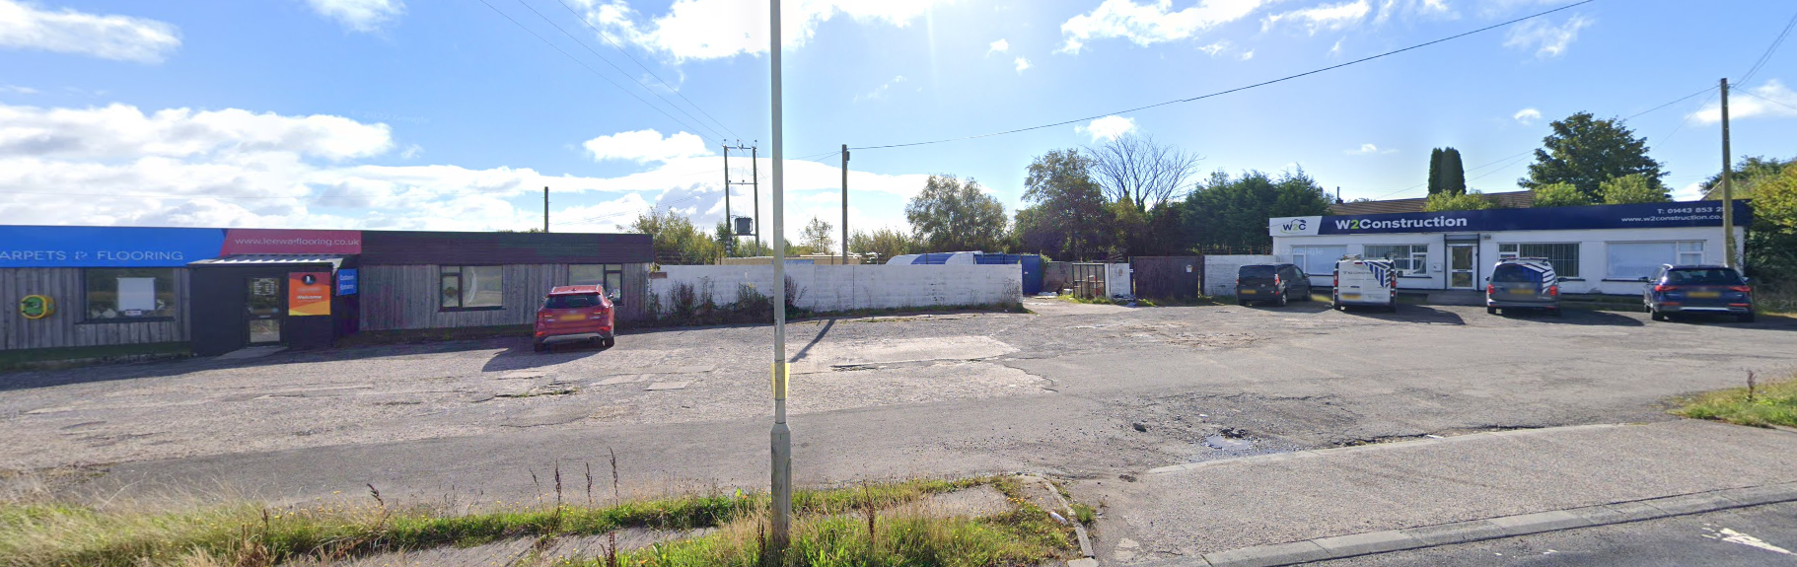

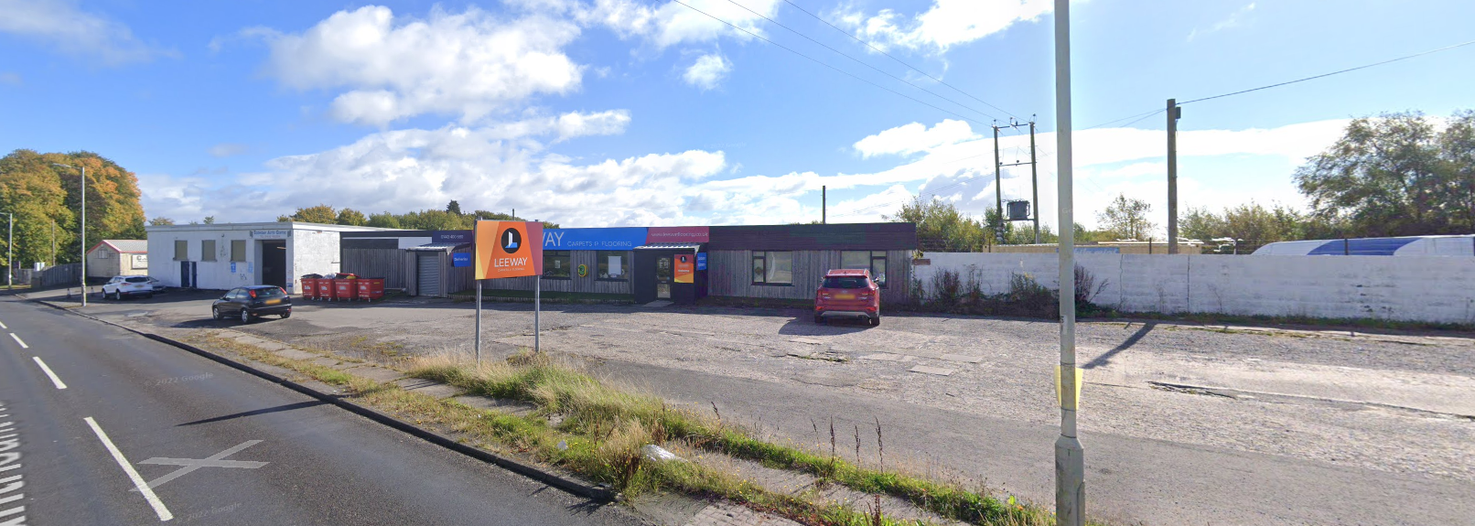

Residential Amenity

  - The proposed development is within an existing commercial site which has a very long history of business use, so any adjacent residential occupiers will have decided to occupy their homes in the knowledge of the adjacent land use. Notwithstanding this, the proposed development has been carefully designed to ensure no detriment to the privacy or amenities of these adjacent occupiers.

  - The proposed development is for single storey buildings and this differs from the previously approved scheme on site (20/0158/10) which was two storey in design and included fenestration at first floor level. The proposed scheme has limited openings within the end elevation, within proximity to the nearest residential properties (to the south-west). The proposed building (2), which are to provide the area for sales and display, along with office space and staff amenities presents the elevations below, to the closest dwellings.

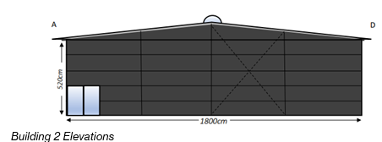

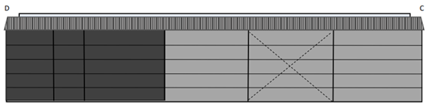
  - The elevations presenting to the closest residential properties have no openings and very little in the way of fenestration. Therefore, there is very limited opportunity for a prejudicial impact upon residential amenity.

  - The business does not undertake campervan conversions and noise emissions will be limited to activities associated with general maintenance and preparation of vehicles for sale. Therefore, it is not considered that noise from the activities proposed on site would prejudice the amenities of any neighbouring occupiers. As highlighted elsewhere within this submission the position of fenestration and openings has been carefully considered in order to minimise the potential for disturbance for neighbouring occupiers and the proposed wall panelling provides high levels of noise attenuation.

Transport

  - The application site is well served by Llantrisant Road (which runs along the frontage of the application site) and currently provides direct access to the site.

  - The site is well served by public transport and bus stops are readily accessible on foot (a 290 metre or a 315 metre walk) depending on the desired direction of travel. The bus service provides an 11 minute journey time to Pontypridd train station within the heart of the town (using bus 404).

Ecology

  - The site is not subject to any specific designations and is outside of and not directly adjacent to the Pen-y-Coedcae Grassland Site of Important Nature Conservation (AW 8.128). The application site is hardsurfaced in its entirety and offers no potential habitat for protected species. The building proposed for demolition have been surveyed for bats and the bat report is submitted in support of this application.

Design and Access Statement

Character and Context

  - The proposed development has considered the objectives of good design, as identified within TAN 12: Design. The village of Penycoedcae contains a range of different styles of property ranging from utilitarian commercial buildings, to residential properties of both single and two storey construction. The finishing materials also vary widely, with examples of painted blockwork, a range of differing types of painted render, natural stone and stone cladding. Roofing materials also vary from natural slate to synthetic slate and concrete tiles, along with flat roofing systems to the commercial units.

  - The proposed development will significantly improve the appearance of the site, which consists of two dilapidated commercial buildings which have exceeded their natural lifespan. The site is inefficiently used, is not laid out for car parking and consists of ad hoc parking across an expanse of hard standing of varying low quality.

  - The proposed development has been designed with a contemporary approach with a particular attention to detail and the use of quality materials, which provide high levels of acoustic attenuation. The proposed building will be seen in the context of the existing adjacent commercial premises and will significantly improve the appearance of the site.

Access and Movement

  - The proposed development will rationalise the existing layout, which does not benefit from being laid out for parking and manoeuvring. The layout provides a suitable amount of off-street parking, whilst providing a more logical layout and understanding of how pedestrians will move through the site.

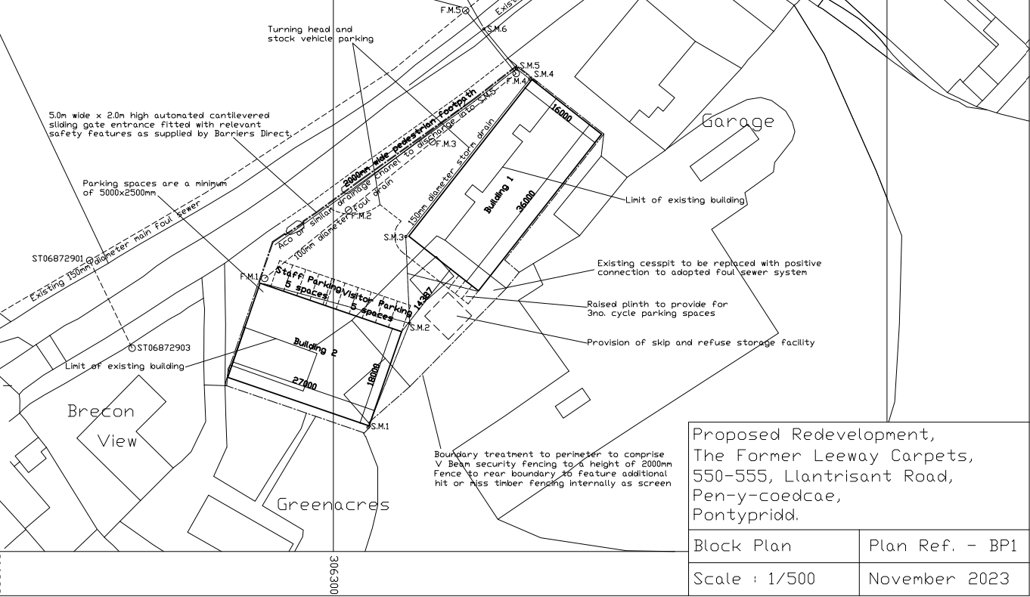
Proposed Site Plan

  - Access to the building is to be provided across a flush entrance ensuring suitable access for all.

  - The development will also provide for the reinstatement of the public footway along the length of the premises with the public highway. Presently there are gaps in the public footway where redundant vehicular crossovers exist. The reinstatement of the public footway will provide benefit to users of the site and general betterment for pedestrians accessing Penycoedcae.

Community Safety

  - The proposed building has been designed to provide good levels of natural surveillance with fenestration facing over Llantrisant Road and the carpark to the front of the premises. A security gate is also proposed at the entrance to the site with Llantrisant Road in the interests of crime prevention.

Environmental Sustainability

  - The vacant site currently represents a waste of resource. The site is occupied by poorly constructed buildings which are beyond their natural lifespan and not economically viable to repair. The site will continue to decay and blight the local area, with its dilapidated appearance, unless wholescale redevelopment is approved by the LPA.

  - The proposed development will enable an efficient use of the site, through greater site coverage. Furthermore, the proposal is for the construction of buildings which perform highly with regard to thermal and acoustic efficiency.

  - The proposed buildings are not to be constructed speculatively but are to be constructed on behalf of a highly respected, long established, local business and employer, which is seeking to enable their business to continue to grow in a sustainable manner.

  - The proposed development will enable the demolition of two aged buildings which are of poor construction and offer very little in terms of thermal insulation. The proposed building will offer high quality, purpose built accommodation which is built to modern construction standards with high levels of insulation. The energy requirements and associated operating costs for the new building will be significantly lower than the existing premises, despite the increase in floorspace and the number of employees on site.

- CONCLUSIONS

  - This Planning, Design and Access Statement provides a detailed examination of the relevant material planning considerations for the proposed development.

  - In conclusion, on the basis of a comprehensive review of both planning policy, the design of the proposed works, Planning Permission should be granted for the following reasons:
- The proposed development would enable significant investment in a site which is derelict and in very poor condition, is unfit for purpose and is unattractive for commercial use, in its current form;
- The proposed development would enable a local business to continue to grow and flourish and to employ additional local people and provide a significant boost to the local economy; and
- The proposed redevelopment of the site would significantly improve the visual amenities of the site, which currently appears dilapidated; and
- The proposed development would deliver a reinstated length of footway along the frontage of the site, to the benefit of community safety and sustainability.

  - Having regard to the above key considerations, it is considered that the proposed development adheres to the provisions of both National and local policy.

  - Accordingly, the proposal should be supported by the Local Planning Authority and we request that Planning Permission be granted.

